Global ICT

Unit / Unit

|  |
| --- |
|  |
| POWERGIS - SERVICIO |
| SM200-Project Plan & Cost Estimation |
|  |
|  |
|  |
| This document contains proprietary information of Enel SpA and shall only be used by the recipient in relation to the purposes for which it was received. Any form of reproduction or disclosure without the express consent of Enel SpA is prohibited. |
|  |

|  |  |  |
| --- | --- | --- |
| Written by: | Juan David Naranjo | 27/04/2020 |
| Verified by: |  |  |
| Approved by: | Juan Camilo Atencia | 27/04/2020 |

|  |  |  |  |  |  |  |
| --- | --- | --- | --- | --- | --- | --- |
| **Project Info** | | | | | | |
| **ICT Legal Entity** | | |  | Legal entity in which the budget for the investment is allocated. | | |
| **Business Legal Entity** | | |  | Business Legal Entity the project belongs to | | |
| **Business Area** | | |  | Business Area the project belongs to | | |
| **Geographical Area - Region** | | |  | Region of the project. | | |
| **Geographical Area - Country** | | |  | Country/countries affected by the project. | | |
| **Cost Category** | | | Growth |  | | |
|  | Chose a Level 1 / Level 2 Category | | |
| Run |  | | |
|  |  | | |
| **APM Code** | | |  | Application code defined in APM | | |
| **Applicant** | | |  | With this driver, the source for the initiative set up is identified. Choosing between internal or business initiatives, implies that actors will be different and/or involved differently in the initiative set up and development. | | |
| **Initiative Type** | | |  | Initiative Type is a driver used to evaluate what type of initiative is going to be set up, dependently on the need for an infrastructural or applicative initiative. | | |
| **Development Type** | | |  | Development Type is a driver that differentiates the initiatives based on their intervention perimeter relatively to budget, men days and impact on the overall system. | | |
| **Methodology** | | |  | Methodology used for the project. | | |
| **Incident categorization (Only for Correctives)** | | **Impact** |  | Service downtime impact on the Business, to be estimated considering the potential damage coming from an extended service interruption. | | |
| **Urgency** |  | Maximum elapsed for incident resolution, mostly depends on SLAs and OLAs involved | | |
| **Data Protection Law Appliance** | | |  | Indicate if the solution if subjected to Data Protection Law | | |
| **SoD Appliance** | | |  | Indicate if the solution if subjected to Separation of Duties | | |
| **Template Info** | | | | | | |
| **Name** | SM200-Project Plan & Cost Estimation | | | | **Version** |  |
| **Written by** | *Insert name and function / unit / company of the template writer.* | | | | **Date** | *dd/mm/yyyy* |
| **Verified by** | *Enter the name and role of the person verifying the template.* | | | | **Date** | *dd/mm/yyyy* |
| **Approved by** | *Enter the name and role of the person approving the template.* | | | | **Date** | *dd/mm/yyyy* |

Distribution List

*List of recipients and delivery modes of the document. For example:*

|  |  |
| --- | --- |
| **Name** | **Reference** |
| Andrea Leguizamon | [andrea.leguizamon@enel.com](mailto:andrea.leguizamon@enel.com) |
|  |  |

*The document is sent by mail and is still available on the web site / FTP Server.*

Changes to the document

*The changes in the document must be detailed in this table:*

|  |  |  |  |  |  |
| --- | --- | --- | --- | --- | --- |
| **version control** | | | | | |
| **Date** | **Version** | **Written by** | **Reviewed by** | **Section** | **Changes description** |
| 27/04/2020 | 1 | Juan David Naranjo |  |  | Creación del documento |
|  |  |  |  |  |  |
|  |  |  |  |  |  |
|  |  |  |  |  |  |
|  |  |  |  |  |  |

Table 1 – Version Control

References

1. Author, Title of the first document, Publisher, Month 20XX
2. Author, Title of the first document, Publisher, Month 20XX

Index

1. Definitions, acronyms, abbreviations 5

2. Glossary 6

3. Introduction 7

4. Project Description 8

4.1. Project Description 8

4.2. Objectives 8

4.3. Proceso Actual 8

4.4. Esquema Funcional Solución 9

4.5. Project Scope 9

4.6. Project Prerequisites and Constraints 10

4.6.1. Prerequisites 10

4.6.2. Other Constraints 12

4.7. Key Success Factors 12

5. Project Planning and Phases 13

5.1. Methodology 13

5.2. Project Phases and Milestones 13

5.3. Project Planning 15

5.4. Material and Technological Resources 16

5.5. Work Team / Roles and Responsibilities 17

5.6. Cost Estimation 17

5.7. Change Management 18

5.8. Conceptual Solution 18

6. Documentation Plan 19

7. Communication, Monitoring and Control Plan 20

8. Training Plan 21

9. Risks Plan 22

10. Security Controls 25

11. Peer-Review Strategy 26

12. Quality Plan 27

13. Annexes 28

14. Standards and Tips 29

Index of figures and tables 30

# Definitions, acronyms, abbreviations

*List of definitions of specific terms used in the document or ICT terms that will be also used in further documents. List of Acronyms. Full description of each adopted abbreviation.*

|  |  |
| --- | --- |
| **Acronym** | **Description** |
| *VPN* | *Virtual Private Network* |
| *ICT* | *Information and Communication Technology* |
| *IDS* | *Intrusion Detection System* |
| *WLS* | *WebLogic Server* |
| *Windows XP SP2/SP3* | *Windows XP Service Pack2/Service Pack 3* |
| *IE8* | *Internet Explorer 8* |
| *SOA* | *Service-Oriented Architecture* |
| *SAP RFC* | *SAP Remote Function Call* |
| *SAP IDOC* | *SAP Intermediate Document* |
| *SAP JCO* | *SAP Java Connector* |
| *SOAP* | *Simple Object Access Protocol* |
| *XML* | *eXtensible Markup Language* |
| *ETL* | *Extraction, Transformation and Loading* |
| *WS* | *Web Service* |

Table 2 – Definitions, acronyms, abbreviations

# Glossary

*List of definitions used in this document.*

|  |  |
| --- | --- |
| **Term** | **Meaning** |
| *Functional diagram* | *Structured representation of the functions (activities, actions, processes, operations) within the system or one of its parts.*  *The model aims at facilitating the identification of information needs and helping to recognize opportunities.* |
| *Component diagram* | *Diagram which has the purpose of representing the internal structure of the software system modeled in terms of its main components and the relationships between them.*  *A component is a software unit with a distinct identity, as well as distinct responsibility and well-defined interfaces.* |
| *Deployment diagram* | *Diagram which describes a system in terms of hardware resources, nodes, and relationships between them.*  *Often there is a diagram showing how the software components are distributed with respect to the available hardware resources on the system.*  *In essence, it shows the physical location (deployment) of components in the architecture* |
| *Activity diagram* | *The process view is a way of showing what the system does at a high level from a process prospective, explaining how the small steps within the process fit together, in terms of order and flow of information.* |
| *Use case diagram* | *Diagram representing the actors outside of a system capable of interacting with the system itself. It represents the highest level view of a system.*  *Shows the system as a whole and its input and output to and from external elements.* |

Table 3 – Glossary

# Introduction

El objetivo de este documento es especificar la información de las indisponibilidades planeadas que se va a enviar desde el sistema InGEN al sistema PowerGis, tomando como base la actual interfaz que dispone InGEN para el envío de Indisponibilidades.

# Project Description

|  |  |
| --- | --- |
| **ID Requerimiento** | **Descripción** |
| 1 | Elaborar servicio web para guardar la infomacion de indisponibilidad del sistema InGENen en la base de datos de PowerGis. |
| 2 | Desarrollar servicio web que es exponga la informacion de disponibilidad de PowerGis. |

## Project Description

Se requiere guardar del sistema InGEN en la base de datos de PowerGis y posteriormente exponer la información de PowerGis a través de servicios web.

## Objectives

Tener en tiempo real la infomación de InGEN en la base de datos de PowerGis.

## Project Scope

Crear un servicio que guarde la informacion de InGEN en PowerGis y otro que muestre la informacion de PowerGis cuando se requiera.

## Project Prerequisites and Constraints

## N/A

### Prerequisites

### N/A

### Other Constraints

*Other constraints affecting the beginning of the project, such as physical access to building, work stations…*

## Key Success Factors

*Specify the factors identified as necessary to successfully conclude the project. They may be activities, data, procedures, general management concepts… This is not a mandatory section.*

*Example: Scope Management, Deviation Management, Expectation Mangement…*

# Project Planning and Phases

## Methodology

• Reuniones de informe de tareas diarias

• Informe de avance todos los viernes mediante el acta propuesta

• Según la actividad del cronograma, el Usuario funcional trabajara con el desarrollador para avanzar en las dudas rápidamente.

• Entregas parciales y pruebas por cada módulo.

## Project Phases and Milestones

*Describe the activities within each phase of the project. This is a mandatory section.*

|  |
| --- |
| Nombre de tarea |
| **Servicio SOAP disponibilidad** |
| **Organización de proyecto** |
| Kick-off del proyecto |
| Gestion |
| **SPRINT 1** |
| HU1 back-end crear servicio soap que guarda los datos de indisponibilidad |
| HU2 back-end pruebas del servicio |
| HU3 back-end crear servicio rest para exponer los datos de indisponibilidad |
| **Cierre de evolutivos Solicitudes** |
| Retrospective |
| Acta de Cierre |
| **Aprobación final** |

Table 4 – Phases and Activities of the project

|  |  |  |  |
| --- | --- | --- | --- |
| Nombre de tarea | Duración | Comienzo | Fin |
| **Servicio SOAP disponibilidad** | **10,25 días** | **lun 27/04/20** | **lun 11/05/20** |
| **Organización de proyecto** | **0 días** | **lun 27/04/20** | **lun 27/04/20** |
| Kick-off del proyecto | 0 días | lun 27/04/20 | lun 27/04/20 |
| Gestion | 10 días | lun 27/04/20 | vie 8/05/20 |
| **SPRINT 1** | **10 días** | **lun 27/04/20** | **vie 8/05/20** |
| HU1 back-end crear servicio soap que guarda los datos de indisponibilidad | 4 días | lun 27/04/20 | jue 30/04/20 |
| HU2 back-end pruebas del servicio | 2 días | vie 1/05/20 | lun 4/05/20 |
| HU3 back-end crear servicio rest para exponer los datos de indisponibilidad | 4 días | mar 5/05/20 | vie 8/05/20 |
| **Cierre de evolutivos Solicitudes** | **0,08 días** | **lun 11/05/20** | **lun 11/05/20** |
| Retrospective | 0,6 horas | lun 11/05/20 | lun 11/05/20 |
| Acta de Cierre | 0 días | lun 11/05/20 | lun 11/05/20 |
| **Aprobación final** | **0 días** | **lun 11/05/20** | **lun 11/05/20** |

Table 5 – Milestones of the project

## Project Planning

*Diagram with all the activities, deliverables and milestones of the project. A Gantt Diagram is proposed, but any diagram showing the most relevant information of planning of the project can be used. A file generated with a project management software can also be embedded. This is a mandatory section.*

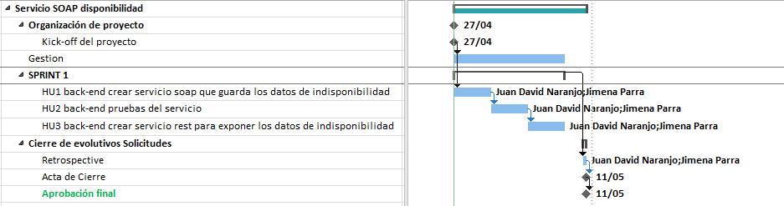

Figure 1 – Gantt Diagram

## Material and Technological Resources

*List of material and technological resources required for successful completion of the project. Example of material resources: rooms, work stations, access to facilities… Example of technological resources: internet access, new software licenses, databases, servers… This is a mandatory section.*

|  |  |  |
| --- | --- | --- |
| **Resource** | **Description** | **Iteration Nº** |
| Entorno de Desarrollo | Servidor de pruebas unitarias y desarollo | *x* |
| Entorno calidad | Entorno de pruebas de Usuario | *x* |
| Entorno de Produccion | Servidor de produccion | x |

Table 6 – Material Resources

## Work Team / Roles and Responsibilities

*Describe the different roles and functions for each of the work team members. Both external and internal teams should be detailed. It could contain an organigram of the teams.*

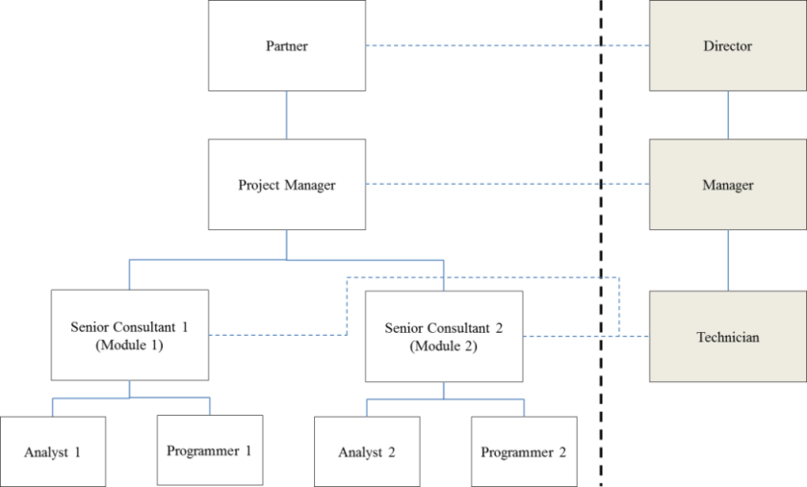

EXAMPLE

Figure 2 – Organigram (example)

## Cost Estimation

A continuación se describen las actividades y precios considerados para la implementación de la solución descrita en el detalle de los objetivos descritos anteriormente.

|  |  |
| --- | --- |
| **Tasa/Día COP$** | **$ 556.346,86** |

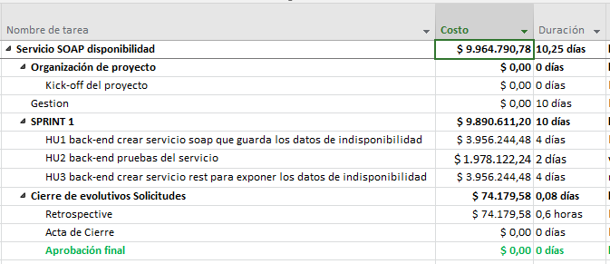

|  |  |  |
| --- | --- | --- |
| **Total Esfuerzo** | **10,25 días** | **$ 9.964.790,78** |
| **Total Neto (sin IVA)** |  |  |

Table 9 – Cost Estimation

## Change Management

*This table helps manage the different changes in the requirements of the project.*

| **Change Name** | **Requested by** | **Request Date** | **Hours Estimation** | **Comments** |
| --- | --- | --- | --- | --- |
|  |  |  |  |  |
|  |  |  |  |  |
|  |  |  |  |  |
|  |  |  |  |  |
|  |  |  |  |  |

Table 10 – Change Management

## Conceptual Solution

*Detailed description of the technological architecture of the application. Describe the technological elements within the scope of the project.*

# Documentation Plan

*List of Solution Management deliverables. Indicate which deliverables need to be drafted as well as due dates and people in charge.*

*List of deliverables:*

* *Risk Analysis Doc.*
* *User Requirement Doc.*
* *Project Plan & Cost Estimation Doc.*
* *Architectural Blue Print*
* *Functional Design Doc.*
* *UAT Document*
* *Technical Design Doc.*
* *Package Installation Manual*
* *Operating Manual*
* *User Manual*
* *User Acceptance Test Result*
* *Monitoring Manual*

|  |  |  |  |  |
| --- | --- | --- | --- | --- |
| **Project/Subproject:** | | | | |
| **Deliverable Name** | **Comment** | **Responsible** | **Delivery Due Date** | **Validation Due Date** | |
|  |  |  |  |  | |
|  |  |  |  |  | |
|  |  |  |  |  | |
|  |  |  |  |  | |
|  |  |  |  |  | |
|  |  |  |  |  | |
|  |  |  |  |  | |
|  |  |  |  |  | |
|  |  |  |  |  | |

Table 11 – Deliverables

# Communication, Monitoring and Control Plan

*Only applicable to standard projects. Describe communication-level interrelations to be maintained between the different resources of the project. For example:*

* *Kick-off meeting*
* *Project Plan Presentation*
* *Milestone Approval Communication*
* *Periodic Monitoring Meetings*
* *Project Closure Communication*
* *Etc.*

*Provide a detailed description of the different meetings to be held during the project, the communication process and coordination of other projects in parallel.*

|  |  |  |
| --- | --- | --- |
| **Committee/Meeting** | | |
| **Name** | **Affected Profiles** | **Periodicity** |
|  |  |  |
|  |  |  |
|  |  |  |
|  |  |  |
|  |  |  |

Table 12 – Meetings

# Training Plan

*Describe the Training Plan: intended users, training needed, dates and calendar, manual elaboration…*

# Risks Plan

*The objective of this section is to present the risks identified in the project, in order to control and manage them. Specific action will be described so that they can be followed in the event that a given risk occurs. The following table has to be completed:*

* ***Risk Description:*** *brief description of the characteristics of the risk.*
* ***Status****: current status of the risk (active, occurred, expired).*
* ***Detection Date:*** *date the risk was detected.*
* ***Risk Impact:*** *in order to determine the severity and magnitude of the occurrence of a risk. Possible values are:*
* *High.- It does not allow the service or project to continue.*
* *Medium.- It allows the service or project to continue but has to be corrected quickly in order to maintain the continuity.*
* *Low.- It allows the service or project to continue.*
* ***Probability of Occurrence:*** *measures the probability that the risk occurs. Possible values are:*
* *Very High.- The risk has occurred repeatedly in similar projects.*
* *High.- There is a high degree of probability that the risk will occur.*
* *Medium.- Depending on the circumstances the risk may occur.*
* *Low.- The risk seldom occurs.*
* *Very Low.- The risk only occurs under exceptional circumstances.*
* ***Mitigating Action:*** *actions to decrease the probability that the risk will occur.*
* ***Responsible:*** *person in charge of the mitigation of the risk*

*In order to facilitate the risk identification process, most common risks have already been proposed in the table. It is necessary to eliminate the risks that don’t apply to the project and add the risks that are not already written.*

| **ID** | **Risk Description** | **Status** | **Detection Date** | **Probability of Occurrence** | **Risk Impact** | **Mitigating Action** | **Responsible** |
| --- | --- | --- | --- | --- | --- | --- | --- |
| ***1*** | *Project cost does not match with initial estimations for this kind of projects* |  |  |  |  |  |  |
| ***2*** | *The established milestones are not aligned with the typical ones for this kind of projects* |  |  |  |  |  |  |
| ***3*** | *The product is not viable (considering the initial cost estimations)* |  |  |  |  |  |  |
| ***4*** | *System development and release planning is not adequate* |  |  |  |  |  |  |
| ***5*** | *Estimated resources for system development and release are not adequate* |  |  |  |  |  |  |
| ***6*** | *Designated budget for system development and release is not adequate* |  |  |  |  |  |  |
| ***7*** | *Defined phases for software development are not known by all the members of the development team* |  |  |  |  |  |  |
| ***8*** | *Defined phases for the project are not adequate for the needs of the project* |  |  |  |  |  |  |
| ***9*** | *Necessary resources for the project are not available or do not have the required skills/characteristics* |  |  |  |  |  |  |
| ***10*** | *The project does not have enough resources/capacity to face adverse events or variations during the development* |  |  |  |  |  |  |
| ***11*** | *There is no coordination between the teams participating in the project. Lack of communication and/or lack of exchange of information* |  |  |  |  |  |  |
| ***12*** | *Low performance of work teams (lack of experience/knowledge)* |  |  |  |  |  |  |
| ***13*** | *The internal human resources needed for the project are not available* |  |  |  |  |  |  |
| ***14*** | *The products obtained during the development of the project do not meet the time and quality requirements* |  |  |  |  |  |  |
| ***15*** | *Contracts with the external resources do not have an appropriate length for the project* |  |  |  |  |  |  |
| ***16*** | *The teams do not have the tools/technologies they need in order to develop and release the system* |  |  |  |  |  |  |
| ***17*** | *Project information and documentation are not managed according to the company’s policies* |  |  |  |  |  |  |
| ***18*** | *Necessary logistics to ensure the quality of the project are not adequate* |  |  |  |  |  |  |
| ***19*** | *There is lack of commitment from top management* |  |  |  |  |  |  |
| ***20*** | *The project is not aligned with the fundamental policies and regulations of the organization* |  |  |  |  |  |  |
| ***21*** | *User and technological requirements are not well expressed and understood by the project teams* |  |  |  |  |  |  |
| ***22*** | *The proposed architecture does not satisfy the defined requirements of needed operating capabilities* |  |  |  |  |  |  |
| ***23*** | *The design of the system does not guarantee interoperability and integration with other systems* |  |  |  |  |  |  |
| ***24*** | *Final users do not approve of the system* |  |  |  |  |  |  |
| ***25*** | *Actions for the spreading of the system across users, Operations, HelpDesk… have not been adequate* |  |  |  |  |  |  |

Table 13 – Risks Plan

# Security Controls

*Detailed description of the activities and resources to ensure that the security policies, standards and regulations of the company are followed*

# Peer-Review Strategy

*If the project will count with internal resources, introduce the Peer-Review strategy to be followed in order to ensure the quality and integrity of the coverage of the different User Requirements. Specific Peer-Review activities should be provided, along with the main responsibilities of each “Peer”. If the project is going to be carried out with external resources, this section appears in the SM100 template. Fill this section only if it applies to the project.*

# Quality Plan

*Detailed description of the activities and resources to ensure that the quality policies, standards and regulations of the company are followed*

# Annexes

*Include any reference document or any other relevant information to be considered.*

# Standards and Tips

*All sections of this template may or may not be filled with information, depending on the nature of the project. Whenever a section does not apply to the project, the user will indicate “Not Applicable” in the body of the section, in order to indicate that the section provides no   
required information for the specific project.  
  
Where possible, the use of the following UML standard diagrams is suggested:*

1. *Use cases diagram*
2. *Component diagram*
3. *Functional diagram*
4. *Activity diagram*
5. *Deployment diagram*

Index of figures and tables

Figures

Figure 1 – Gantt Diagram (example) 3

Figure 2 – Organigram (example) 3

Tables

Table 1 – Version Control 3

Table 2 – Definitions, acronyms, abbreviations 3

Table 3 – Glossary 3

Table 4 – Phases and Activities of the project 3

Table 5 – Milestones of the project 3

Table 6 – Material Resources 3

Table 7 – Technological Resources 3

Table 8 – Technological Resources 3

Table 9 – Cost Estimation 3

Table 10 – Change Management 3

Table 11 – Deliverables 3

Table 12 – Meetings 3

Table 13 – Risks Plan 3